The green axis (Z axis)

will be the rotation axis. The pivot point is at the origin.

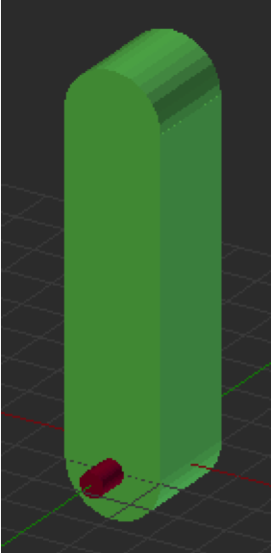

The green axis (Z axis)

will be the rotation axis. The pivot point is at the origin.

